Master Functional Document

Application | NGERP - Centra
Service Bundle | Master Management
Service Request | Sales Region Mapping

Description :

The address for the business partner is created in sales region mapping master. It is mapped in the location tab in manage partner maaster.

Workflow Process :

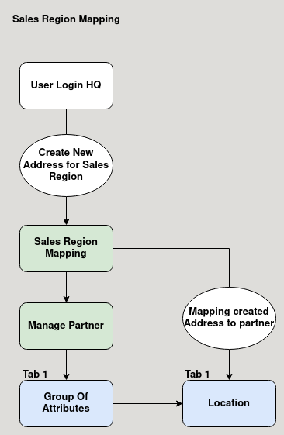

Business Rules :

- User Should login as HQ to create new sales region mapping.
- Sales region mapping is not editable in region.
- The created address is mapped to the business partner in manage partner location tab.
- The address for the partner will load from the sales region mapping master.

